Silver Nutmeg Bowl
JLD
Awarded to the highest placed EDRC Member in the Open Class at the Area Horse Trials
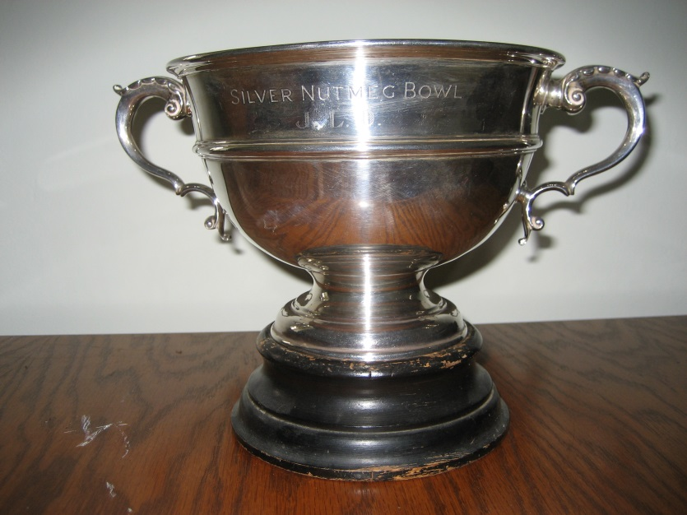
Presented in memory of Silver Nutmeg, a winning point to point horse, and Joan Depree who were one of the combinations that helped the Club to claim victory at the National RC Horse Trials Championships in 1969.

Exeter & District Riding Club
Novice Area Horse Trials Trophy
Awarded to the highest placed EDRC Member in the Novice 90cm Class at the Area Horse Trials
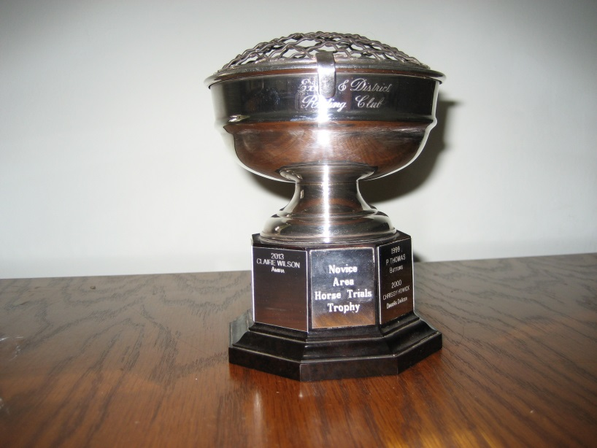
The Benson Trophy
Awarded to the highest placed EDRC Member in the Novice 80cm Class at the Area Horse Trials
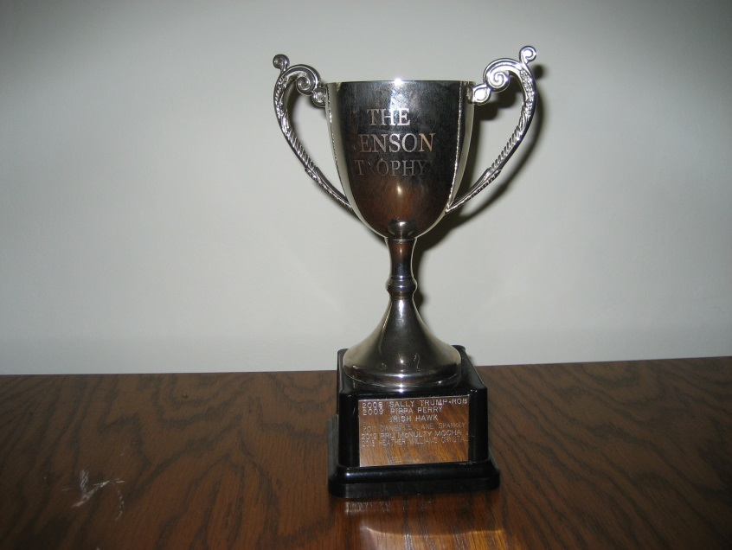

Sanders Memorial Trophy
Awarded to the highest placed EDRC Member in the Intermediate 100 Class at the Area Horse Trials
